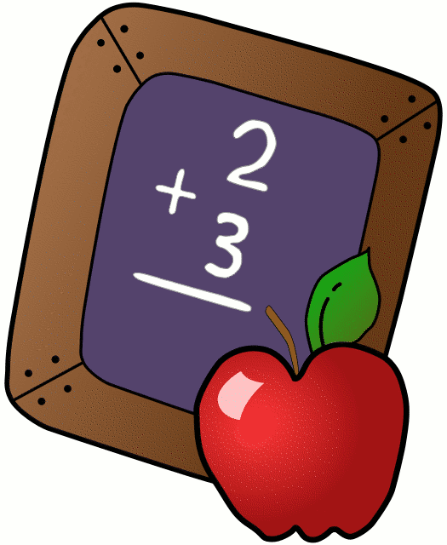
Homework 1/7 – 1/11
Mrs. Radcliffe’s 2nd Grade

 | Monday | Tuesday | Wednesday | Thursday
Math | Complete  Pg. 103 & 104 | Complete  Pg. 105 & 106 | Complete  Pg. 107 & 108
Language Arts | 3 Xs Each | Complete  Pg. 101 | Complete  Pg. 102
Spanish | 5C Harder due tomorrow | Complete 5C for next Tuesday’s class
Religion | Scripture Test 1/18. |  |  | Reconciliation  6:30p.m.
Projects/Other | Begin  Ellis Island Project
Notes From Mrs. Radcliffe:
- Welcome back! I hope everyone had a wonderful break.
- Reconciliation is THIS THURSDAY. COMPLETED books were due before break. They must be completed and submitted BY TUESDAY 1/8!!! This is mandatory for participation. If you have not turned yours in yet, GET IT IN!
- Reconciliation is at 6:30p.m. Please arrive by 6:20 and find a seat quiety as a family. Students should wear church appropriate clothing.
- Reading forms were due before break. If you have not turned it in, make sure you do.
- Open House: Sunday January 27th!
- Catholic Schools Week: January 28th- Feb 2nd.
- 2nd Grade Mass Friday January 25th.

Name_____________

Weekly Behavior Log

How was my behavior today? | Mon. | Tues. | Wed. | Thurs. | Fri.
Rockin’ Behavior
(Outstanding)
Rockstar Behavior
(Great Job)
Can I Have Your Autograph
(Good Day)
Let’s Rock & Roll
(Ready to Learn)
Singin the Blues
(Think About It)
Speak to Management
(Teacher Choice)
Tour Canceled
(Parent Contact)

Parent/Teacher Communication: _________________________
__________________________________________________________ __________________________________________________________
Parent Signature:_______________________________

