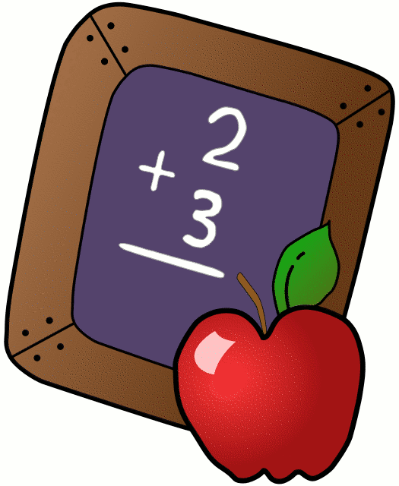
Homework 10/10-10/13
Mrs. Radcliffe’s 2nd Grade

 | Monday | Tuesday | Wednesday | Thursday
Math |  | Study guide  Chapter 2 Test tomorrow! | Chapter 2  Test!  No Homework | Complete  Pg.34
Language Arts |  | Read for fun! | Read for fun! | Read for fun!
Religion |  | Scripture test next Friday! |  | Mass is tomorrow morning!
Spanish |  | 2D due next week
Projects/Other |  | Book Reports due THIS Friday!

Notes From Miss Williams:
- This week we will be wrapping up Unit 1 in our Reading program. The students will be completing several assessments during class and we will be doing a unit study on Stellaluna. There will not be any spelling or vocab this week.
- Book Reports are due on Friday!
- My scholastic code is: L7FR8
- We are finishing Chapter 2 in math and launching into our new unit on Graphs! The students will be finishing this chapter by completing a Halloween survey & graph in class.
- Please bring in a pumpkin on Monday 10/30 to class. The pumpkin can be any size, we will be using them for a lab on Tuesday!
- Halloween Carnival is on Friday, October 27th from 12-2:45.
- Saint sheets went home on Tuesday! Please fill out your top 3 choices and return to Mrs. Radcliffe!
- Saint Reports are due on Tuesday 10/31

Name_____________
Weekly Behavior Log
How was my behavior today? | Mon. | Tues. | Wed. | Thurs. | Fri.
Outstanding
Great Job
Good Day
Ready TO Learn
Think About It
Teacher’s Choice
Parent Contact

Parent/Teacher Communication: _________________________
__________________________________________________________ __________________________________________________________
Parent Signature:_________________________________

