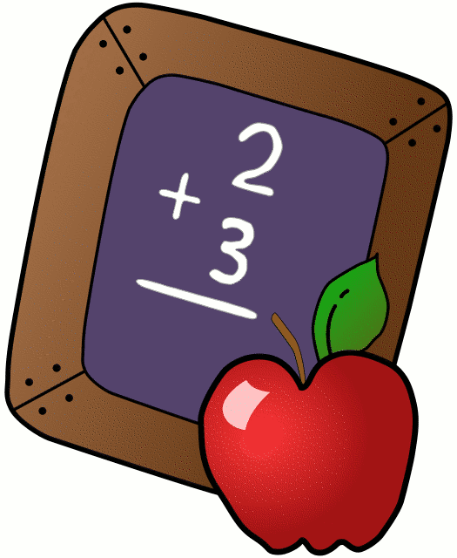
Homework 10/16-10/20
Mrs. Radcliffe’s 2nd Grade

 | Monday | Tuesday | Wednesday | Thursday
Math | Complete  pg. 35 | Complete  pg. 36 | Complete  pg. 37 | Complete  Pg. 38
Language Arts | Amazing Spelling | Rainbow  Write | Pg. 51 | Take a practice test!
Religion | Scripture test Friday |  |  | Mass is tomorrow morning!
Spanish | 2 D due tomorrow! | 3A due next week
Projects/Other | Work on your saint reports

Notes From Miss Williams:
- Friday’s art project has been moved to Thursday, October 19th from 2:00-2:45. Students will be in school families on Friday!
- Science test on States of Matter on Thursday- studying will take place in class- no additional work needs to be done at home.
- My scholastic code is: L7FR8
- We are working on Chapter 3 in math this week. The students will be finishing this chapter by completing a Halloween survey & graph in class.
- Please bring in a pumpkin on Monday 10/30 to class. The pumpkin can be any size, we will be using them for a lab on Tuesday!
- Halloween Carnival is on Friday, October 27th from 12-2:45.
- Saint Reports are due on Tuesday 10/31 (reports can be written neatly or typed).

Name_____________
Weekly Behavior Log
How was my behavior today? | Mon. | Tues. | Wed. | Thurs. | Fri.
Outstanding
Great Job
Good Day
Ready TO Learn
Think About It
Teacher’s Choice
Parent Contact

Parent/Teacher Communication: _________________________
__________________________________________________________ __________________________________________________________
Parent Signature:_________________________________

