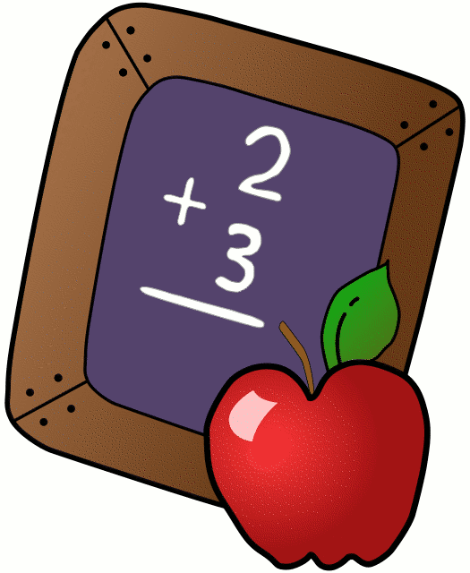
Homework 11/26-11/30
Mrs. Radcliffe’s 2nd Grade

 | Monday | Tuesday | Wednesday | Thursday
Math | Complete  pg. 93 & 94 | Complete  Pg. 95 & 96 | Complete  Pg. 97 & 98 | Complete  Pg. 99 & 100
Language Arts | Rainbow Write | 3xs Each | Amazing Spelling | Study for Spelling & Vocab Test tomorrow!
Spanish | 3C due  tomorrow | Complete 3D for next Tuesday’s class
Religion | Review Scripture for test Friday!  Chapter 3 due in First Rec. Books |  |  | Scripture Test Tomorrow!
Social Studies | Study guide home today Test Thursday. |  | S.S. Test Tomorrow!
Projects/Other | Diorama Book Report extended to next Friday, December 7^{th.}  Reading Forms due Friday! |  |  | Reading Forms Due Tomorrow.
Notes From Mrs. Radcliffe:
- Welcome back! I hope that you all had a wonderful Thanksgiving Break!
- Language Arts: How are offspring like their parents?
  - Phonics: Consonant Digraphs: ch, -tch, sh, ph, th, ng wh
  - Suffixes: -ful, - less
  - Comp: Strategy: reread Skill: Main Topic & Key Details: Genre: Expository Text
- Math- Lesson 8 cont. (Subtracting 2-Digit Numbers)
- Science: Dinosaurs
- Social Studies: America’s Past/ Technology through the years- Test Thurs.
- Religion- Scripture Test on Fri. / First Reconciliation Prep / Advent
- Log your reading in your November Reading Log! Reading Forms are due Friday, November 30th. Book Reports have been extended until Friday, December 7th!

Name_____________

Weekly Behavior Log

How was my behavior today? | Mon. | Tues. | Wed. | Thurs. | Fri.
Rockin’ Behavior
(Outstanding)
Rockstar Behavior
(Great Job)
Can I Have Your Autograph
(Good Day)
Let’s Rock & Roll
(Ready to Learn)
Singin the Blues
(Think About It)
Speak to Management
(Teacher Choice)
Tour Canceled
(Parent Contact)

Parent/Teacher Communication: _________________________
__________________________________________________________ __________________________________________________________
Parent Signature:_______________________________

