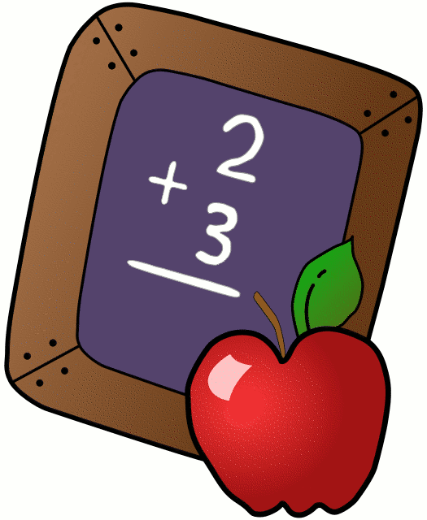
Homework 11/5-11/9
Mrs. Radcliffe’s 2nd Grade

 | Monday | Tuesday | Wednesday | Thursday
Math | Complete  Pg. 73 &74 | Complete  Pg. 75 &76 | Complete  Pg. 77 & 78 | Complete  Pg. 79 &80
Language Arts | Complete  3 Xs Each | Complete  Pg. 37 | Complete  Pg. 38 | Complete  Pg. 39
Spanish | 3A due  tomorrow | Complete 3B for next Tuesday’s class
Projects/Other | Bring in Clay for Coil Bowls next Tuesday

Notes From Mrs. Radcliffe:
- Language Arts- Unit 2.3 (What are features of different animal habitats).
  - Phonics: soft c and g; /j dge, ge, lge, nge, rge. CVCe syllables.
  - Structure: prefixes re, un, dis.
  - Comp Skill: Make, Confirm, Reviese and Predict. Main Topic & Key Details. Genre: Narrative Nonfiction.
  - Writing- Persuasive Piece (Protesting Turkey)
- Math- Lesson 7 (Adding 2-Digit Numbers)
- Social Studies: America’s Past/ Technology through the years
- Religion- Chapter 7 (We think about our choices)
- Log your reading in your November Reading Log!
- All Saints- Please prep your costume for our Christmas Pageant and return them in a sealed Ziplock bag. I will store them until December!
- Clay Dough Recipe- Bring in your dough next Tuesday! See Clay Bowl Sheet that went home today.

Name_____________

Weekly Behavior Log

How was my behavior today? | Mon. | Tues. | Wed. | Thurs. | Fri.
Rockin’ Behavior
(Outstanding)
Rockstar Behavior
(Great Job)
Can I Have Your Autograph
(Good Day)
Let’s Rock & Roll
(Ready to Learn)
Singin the Blues
(Think About It)
Speak to Management
(Teacher Choice)
Tour Canceled
(Parent Contact)

Parent/Teacher Communication: _________________________
__________________________________________________________ __________________________________________________________
Parent Signature:_______________________________

