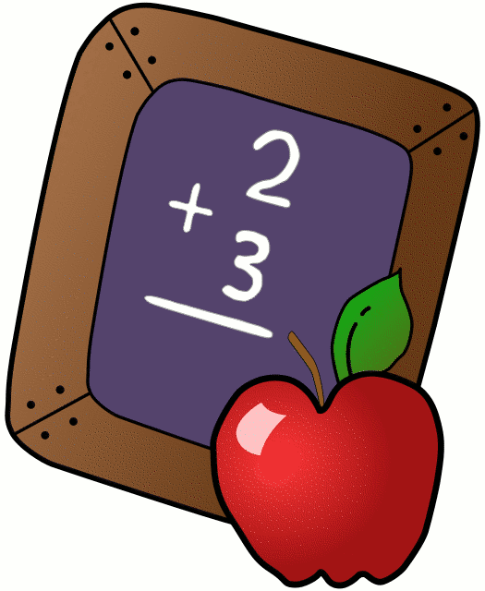
Homework 12/11/17
Mrs. Radcliffe’s 2nd Grade

 | Monday | Tuesday | Wednesday | Thursday
Math | Complete  Pg. 371 | Complete  Chapter 8 Study Guide | Chapter 8 Test today! | Play a Math Fact Game
Language Arts
Religion | Scripture verse. Test 12/15- study |  |  | Scripture Test Tomorrow!
Spanish | 5 A easier due tomorrow | 5B due  next week
Projects/Other | December Kindness Calendar
Notes From Mrs. Radcliffe:
- Continue to work on your Kindness Calendars.
- Unit 2 Assessments in Language Arts- No spelling/vocab this week
- We are doing a 30 day trial of IXL in the classroom. I’m hoping we will be able to continue when our trial runs out! Usernames/Passwords are in the orange folder if they would like to do it at home. (This week and next week are great weeks to work on this at home as there is not much homework.)
- My scholastic code is: L7FR8. Please place all scholastic orders online.
- Harper is star student this week!
- Chapter 8 Math Test this week
- Scripture Test this Friday!
- Bring in Pajamas for our PJ drive!
- Continue to pray for all those effected by the fires!
- Keep up with your Reconcilliation books.

Name_____________
Weekly Behavior Log
How was my behavior today? | Mon. | Tues. | Wed. | Thurs. | Fri.
Outstanding
Great Job
Good Day
Ready TO Learn
Think About It
Teacher’s Choice
Parent Contact

Parent/Teacher Communication: _________________________
__________________________________________________________ __________________________________________________________
Parent Signature:_________________________________

