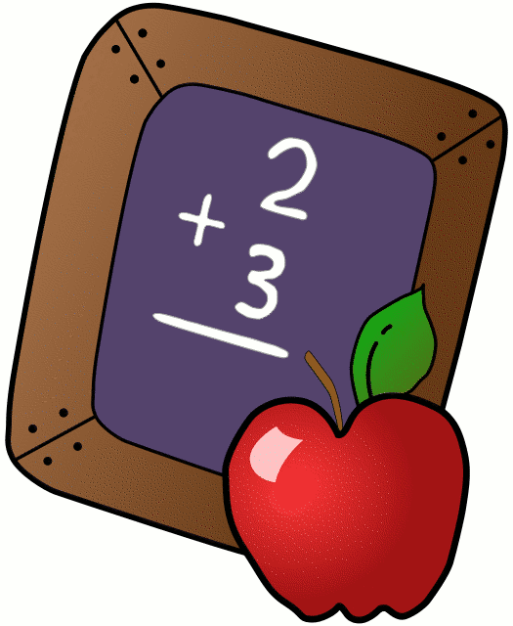
Homework 12/4/17
Mrs. Radcliffe’s 2nd Grade

 | Monday | Tuesday | Wednesday | Thursday
Math | Complete  Pg. 103 | Complete  pg. 104 | Complete  pg. 105 | Complete  pg. 106
Language Arts |  | Complete  Pg. 47 | Complete  Pg. 48 | Complete  Pg. 49
Religion | Scripture verse. Test 12/15- study
Spanish | 5 A easier due tomorrow | 5B due  next week
Projects/Other | December Kindness Calendar

Notes From Mrs. Radcliffe:
- Kindness Calendars went home today! Try to fill them up.
- Advent chains went home on Friday
- We are doing a 30 day trial of IXL in the classroom. I’m hoping we will be able to continue when our trial runs out! Usernames/Passwords are in the orange folder if they would like to do it at home.
- Book Forms should be turned in if they have not yet.
- My scholastic code is: L7FR8. Please place all scholastic orders online.
- Miguel is star student this week!
- Welcome to December!
- Keep up with your Reconcilliation books.

Name_____________
Weekly Behavior Log
How was my behavior today? | Mon. | Tues. | Wed. | Thurs. | Fri.
Outstanding
Great Job
Good Day
Ready TO Learn
Think About It
Teacher’s Choice
Parent Contact

Parent/Teacher Communication: _________________________
__________________________________________________________ __________________________________________________________
Parent Signature:_________________________________

