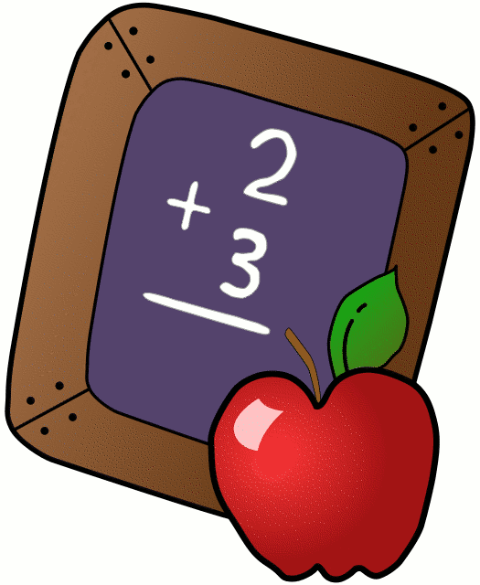
Homework 12/2 - 12/7
Mrs. Radcliffe’s 2nd Grade

 | Monday | Tuesday | Wednesday | Thursday
Math | Complete  Pg. 93 & 94 | Complete  Pg. 95 & 96 | Complete  Pg. 97 & 98 | Complete  Pg. 99 &100
Language Arts | Rainbow Write | Pg. 48 | Amazing Spelling | Study for Spelling & Vocab Test tomorrow!
Spanish | 5A due  tomorrow | Complete 5B for next Tuesday’s class
Religion | Scripture Test next Friday (James 5:8)  Chapter 4 due in First Rec. Books
Projects/Other | Diorama Book Report due THIS Friday!  Reading Forms were due last week! |  |  | Book Reports due tomorrow!
Notes From Mrs. Radcliffe:
- Welcome to Advent!
- Language Arts: How are offspring like their parents?
  - Phonics: 3- letter blends: ch, -tch, sh, ph, th, ng wh
  - Suffixes: -ful, - less
  - Comp: Strategy: reread Skill: Main Topic & Key Details: Genre: Expository Text
- Math- Lesson 8 cont. (Subtracting 2-Digit Numbers)
- Science: Dinosaurs
- Religion- Scripture Test next week / First Reconciliation Prep / Advent
- Log your reading in your December Reading Log! Reading Forms are due Friday, December 22nd . Book Reports have been extended until THIS Friday, December 7th!

Name_____________
Weekly Behavior Log

How was my behavior today? | Mon. | Tues. | Wed. | Thurs. | Fri.
Rockin’ Behavior
(Outstanding)
Rockstar Behavior
(Great Job)
Can I Have Your Autograph
(Good Day)
Let’s Rock & Roll
(Ready to Learn)
Singin the Blues
(Think About It)
Speak to Management
(Teacher Choice)
Tour Canceled
(Parent Contact)

Parent/Teacher Communication: _________________________
__________________________________________________________ __________________________________________________________
Parent Signature:_______________________________

