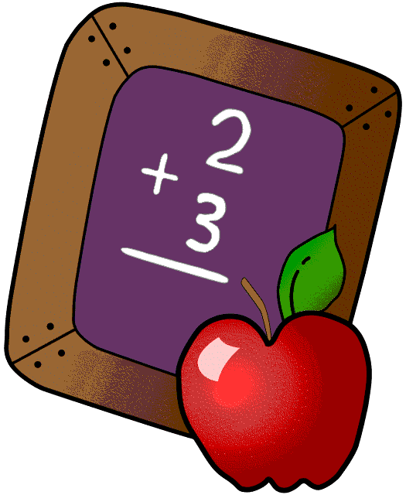Homework 4/1-4/5
Mrs. Radcliffe’s 2nd Grade
 | Monday | Tuesday | Wednesday | Thursday
Math | Complete  Pg. 251 & 252 | Complete  pg. 253 & 254 | Complete  pg. 255 & 256 | Complete  Pg. 257 & 258
Language Arts | iMovie  in-class | iMovie  in-class | iMovie  in-class | iMovie  in-class
Spanish | 8C Adjectives  Due tomorrow | __________  Due next week
Projects/Other | First Communion Banners due 4/15  Career Boxes  (in-class)
Religion | Chapter 6  In First Eucharist Books due today!  Fatima Prayer Test on Friday |  |  | Fatima Test Tomorrow!

Notes From Mrs. Radcliffe
- Thank you to all the parents who came in during Career week! The students loved having you and learning all about your jobs! If you would still like to come in this week, let me know we’d love to have you. Students are working on their career projects in class!
- April is the month of poetry! We will be learning about poems, reading poems and writing poems in class. Please join us for a Poetry Café on Wednesday, April 17th (8:30-9:30). The students will be reading their original poems.
- We finished up Literature Circles in class last week. Students will be making iMovies this week as a final project. I look forward to sharing them with you when they are complete! There will be no spelling/vocab this week as we complete them.
- Fatima test is this Friday!
- Noon Dismissal Friday
- We are working on Money in math this week. If the opportunity comes up, please have your child help you with paying for things to get practice!

Name_____________
Weekly Behavior Log
How was my behavior today? | Mon. | Tues. | Wed. | Thurs. | Fri.
Rockin’ Behavior
(Outstanding)
Rockstar Behavior
(Great Job)
Can I Have Your Autograph
(Good Day)
Let’s Rock & Roll
(Ready to Learn)
Singin the Blues
(Think About It)
Speak to Management
(Teacher Choice)
Tour Canceled
(Parent Contact)

Parent/Teacher Communication: ________________________________________________________________________________________________________________________________________________

Parent Signature:_______________________________

