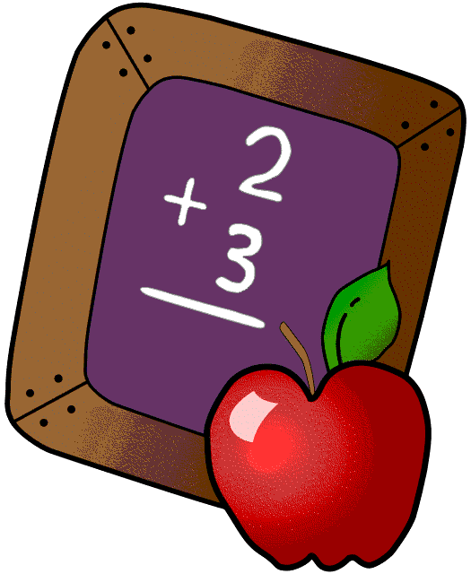Homework 4/15- 4/18
Mrs. Radcliffe’s 2nd Grade
 | Monday | Tuesday | Wednesday | Thursday
Math | Practice Math Facts | Practice Math Facts | Practice Math Facts
Language Arts | Complete  pg. 107 | Complete  pg. 108 | Complete  pg. 109
Spanish | 9A  Due tomorrow | __________  Due next week
Projects/Other | First Communion Banners were due today!
Religion | All Communion books should be turned in & fully completed.

Notes From Mrs. Radcliffe
- Holy Thursday retreat is THIS THURSDAY! I am looking forward to this beautiful day with your children. Feel free to join us at 9:30am in the church for the Washing of the Feet ceremony or at 11:30 for the beautiful Living Stations put on by the 8th grade class.
- The students are finishing up their final Poetry Books. They will be reading their original poems in our annual Poetry Café THIS WEDNESDAY at 8:30am. Feel free to join us! I am so proud of their hard work.
- We finished Unit 3 in math and will be reviewing concepts this week.
- This week is a short week in 2nd grade. Students will still be working through our Wonders curriculum, but they will not be tested on the material.
- Book Reports were due last Friday, the 12th. If they did not get turned in, I will accept them until the Monday we return from break. Reading forms may be turned in this week or when we return from break.
- Get your Belmont Park permission slips in THIS WEEK before break. Thank you to Mrs. Battenfield, Mr. Horvath and Mrs. Mullens for already volunteering to drive!

Name_____________

Weekly Behavior Log
How was my behavior today? | Mon. | Tues. | Wed. | Thurs. | Fri.
Rockin’ Behavior
(Outstanding)
Rockstar Behavior
(Great Job)
Can I Have Your Autograph
(Good Day)
Let’s Rock & Roll
(Ready to Learn)
Singin the Blues
(Think About It)
Speak to Management
(Teacher Choice)
Tour Canceled
(Parent Contact)

Parent/Teacher Communication: ________________________________________________________________________________________________________________________________________________

Parent Signature:_______________________________

