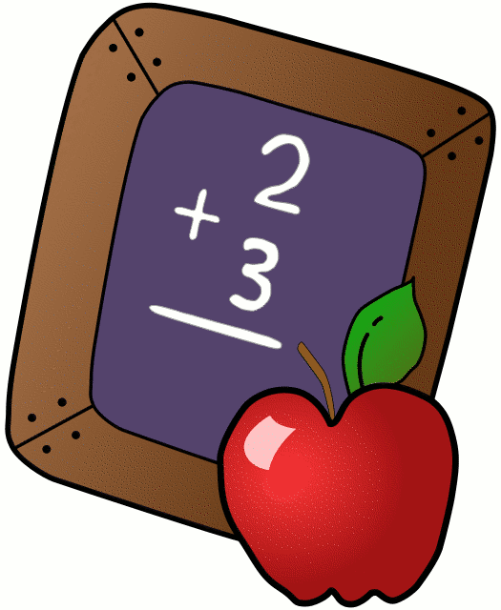
Homework 4/16-4/20
Mrs. Radcliffe’s 2nd Grade
 | Monday | Tuesday | Wednesday | Thursday
Math | Complete  pg. 113 | Complete  Pg. 114 | Complete  Pg. 115 | Complete  Pg. 116 & 117 odds
Language Arts | Study Spell-A-Thon Words & Pledges | Study Spell-A-Thon Words & Pledges | Spell-A-Thon Today
Religion | Chapter 6 First Communion Due today.  Chapter 7 due next week  Scripture Test Friday |  |  | Mass Reflection sheet due on Monday (for all those receiving First Communion)  Scripture Test Tomorrow
Spanish |  | 8 B & C Harder Due today
Social Studies | We are working on projects in class this week. Study guides home today- Test Friday!
Projects/Other | First Communion Banners due Monday! |  | School Family Bingo Tomorrow- Bring Quarters!
Notes From Mrs. Radcliffe:
- Thank you to those of you who have signed up for career week – next week- if you would like to come in, please e-mail me!
- Study for your Spell-A-Thon Test next week! Get your pledges in! The Spell-A-Thon is This Wednesday!
- My scholastic code is: L7FR8. Please place all scholastic orders online.
- Ryder is Star Student this week
- Poetry Café is on Friday, April 27th at 10:00 if you would like to join us.
- Family Activity on April 19th- All School Bingo- Bring in quarters to play with- these will be donated to an Earth Week cause.
- April 25- Natural Resource Test- Study Guide to go home on the 19th. *** Note the date change
- Mass Reflection Sheets will be sent home on Fridays for the next two weeks until First Communion. Please fill them out for and return them on Monday. **** The mass needs to be a Sunday mass (or Saturday night vigil). Please also bring with it the Mass Bulletin from the day you attend. Thanks!

Name_____________
Let’s Rock Your Behavior
How was my behavior today? | Mon. | Tues. | Wed. | Thurs. | Fri.
Rockin’ Behavior

(Outstanding)
Rockstar Behavior

(Great Job)
Can I Have Your Autograph?

(Good Day)
Let’s Rock & Roll

(Ready to Learn)
Singin’ The Blues

(Think About It)
Speak to Management

(Teacher’s Choice)
Tour Cancelled!

(Parent Contact)

Parent/Teacher Communication: _________________________
__________________________________________________________
Parent Signature:________________________________

