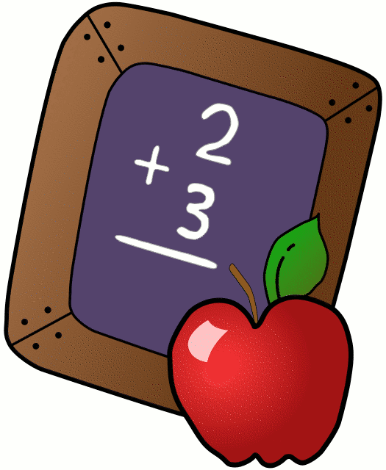
Homework 4/23-4/27
Mrs. Radcliffe’s 2nd Grade
 | Monday | Tuesday | Wednesday | Thursday
Math | Complete  pg. 119 | Complete  Pg. 121 | Complete  Pg. 122 | Complete  Pg. 123
Language Arts | Complete  Pg. 102 | Complete  Pg. 103 | Google Classroom Reflection Sheet | Complete  Pg. 104
Religion | Chapter 7 First Communion Due today.  Chapter 8 due next week  First Communion Vocab Test Next Thursday. Study Guide home today!  Reflection Sheets & Banners due today! |  |  | Mass Reflection sheet due on Monday (for all those receiving First Communion)
Spanish |  | 9 Easier Due today
Science | Natural Resource test on Wednesday! |  | Natural Resource Test Today!
Projects/Other | First Communion Banners due today!
Notes From Mrs. Radcliffe:
- Welcome to career week- we look forward to seeing many of you this week as you share with us your careers!
- Wonders Unit 5.1 went home today- new spelling/vocab
- My scholastic code is: L7FR8. Please place all scholastic orders online.
- Kathleen is Star Student this week
- Poetry Café is THIS Friday, April 27th at 10:00 if you would like to join us. Thank you Mrs. Hanna for bringing in Hot Chocolate and Mrs. Daquipa for bringing in marshmallows.
- April 25- Natural Resource Test
- Mass Reflection Sheets went home on Friday and will go home this Friday. Please fill them out for and return them on Monday. **** The mass needs to be a Sunday mass (or Saturday night vigil). Please also bring with it the Mass Bulletin from the day you attend. Thanks!
- Readings/Petitions for First Communion/May Crowning went home- please practice
- Last week of 3-digit addition & subtraction. Chapter 9 Test will be next Tuesday & we will start our new chapter- Fractions!

Name_____________
Let’s Rock Your Behavior
How was my behavior today? | Mon. | Tues. | Wed. | Thurs. | Fri.
Rockin’ Behavior

(Outstanding)
Rockstar Behavior

(Great Job)
Can I Have Your Autograph?

(Good Day)
Let’s Rock & Roll

(Ready to Learn)
Singin’ The Blues

(Think About It)
Speak to Management

(Teacher’s Choice)
Tour Cancelled!

(Parent Contact)

Parent/Teacher Communication: _________________________
__________________________________________________________
Parent Signature:________________________________

