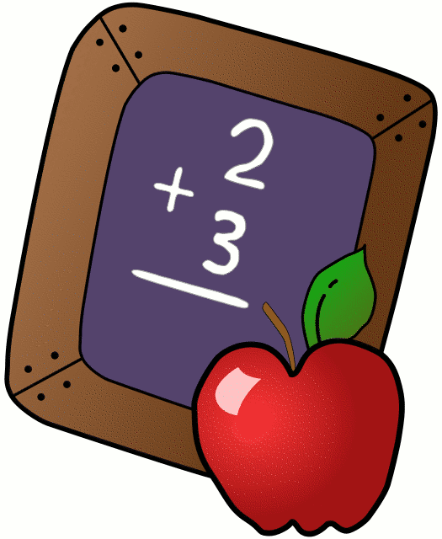
Homework 9/18-9/22
Mrs. Radcliffe’s 2nd Grade

 | Monday | Tuesday | Wednesday | Thursday
Math | Review pg. 12 | Complete  pg.15 | Study Guide Chapter 1 | Chapter 1 Test today  ( No HW)
Language Arts |  | Rainbow Write | Vocab Crossword | Practice Spelling. Test Tomorrow!
Religion |  |  |  | Mass is tomorrow morning!
Spanish | 1C Due Tomorrow | 1D due next week
Projects/Other | Send in a paper bag with your child this week.

Notes From Miss Williams:
- We are working on Map Skills here in 2nd grade. Please send in a paper bag with your child this week, we will be making treasure maps on Friday!
- Please sign the back of this sheet each Friday for your child to turn in to me on Monday!
- I love classroom volunteers. If you would like to help out, please get your live-scan in ASAP!
- Mass- We will be leaving the 2nd grade classroom (with our buddies) at 7:50am to head to the church. If you are here ANY TIME after 7:50 please bring them straight to the church. Thank you!

Name_____________ Week of: 9/18-9/22
Weekly Behavior Log
How was my behavior today? | Mon. | Tues. | Wed. | Thurs. | Fri.
Outstanding
Great Job
Good Day
Ready TO Learn
Think About It
Teacher’s Choice
Parent Contact

Parent/Teacher Communication: _________________________
__________________________________________________________ __________________________________________________________
Parent Signature:_________________________________

