Clay Bowls
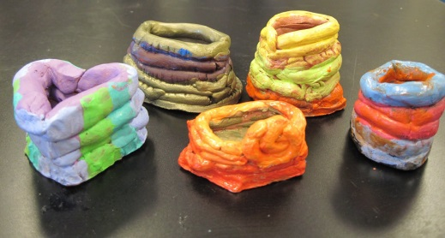

We are learning about America’s Past here in 2nd grade. We are studying many different Native American groups including the Osage. The Osage used grasses to make bowls and baskets. Other groups used many different natural resources to make bowls and other needed items. Your child will be making clay bowls in class by rolling pieces of clay into long strands and then coiling the strands together to make a clay bowl.

You and your child will make the air-dry clay at home to help prepare for the project. Here is the recipe:
1 cup of cornstarch
1-1/2 cup of water (mixed with drops of food coloring or liquid watercolor)
2 cups of baking soda.
Mix and heat the ingredients over a medium-low heat until a dough is formed. Let it cool for a few minutes and then knead the dough like you would do for bread dough.

Please bring your dough to school on Tuesday November 13th in a SEALED zip log bag with your child’s name on it. We will be making our bowls that morning!
- If you have newspaper lying around, could you send some in as well to help cover our work space.

